**Name**-Abhisek Roy

**Department**- B.Tech in Information Technology

**Year-**3rd

**Semester-**5th

**Roll No**-10000219062

**Registration No**-042888

**Paper code** :PCCIT593

Write a bash program to find the perimeter and area of a circle with radius of 5cm.

Answer:

Code:

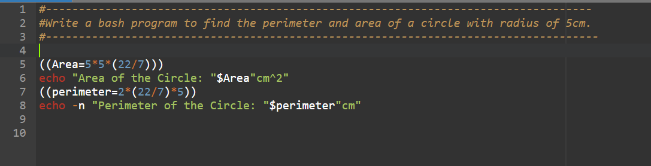

Output :

